Multicultural Youth Talent Show 2021
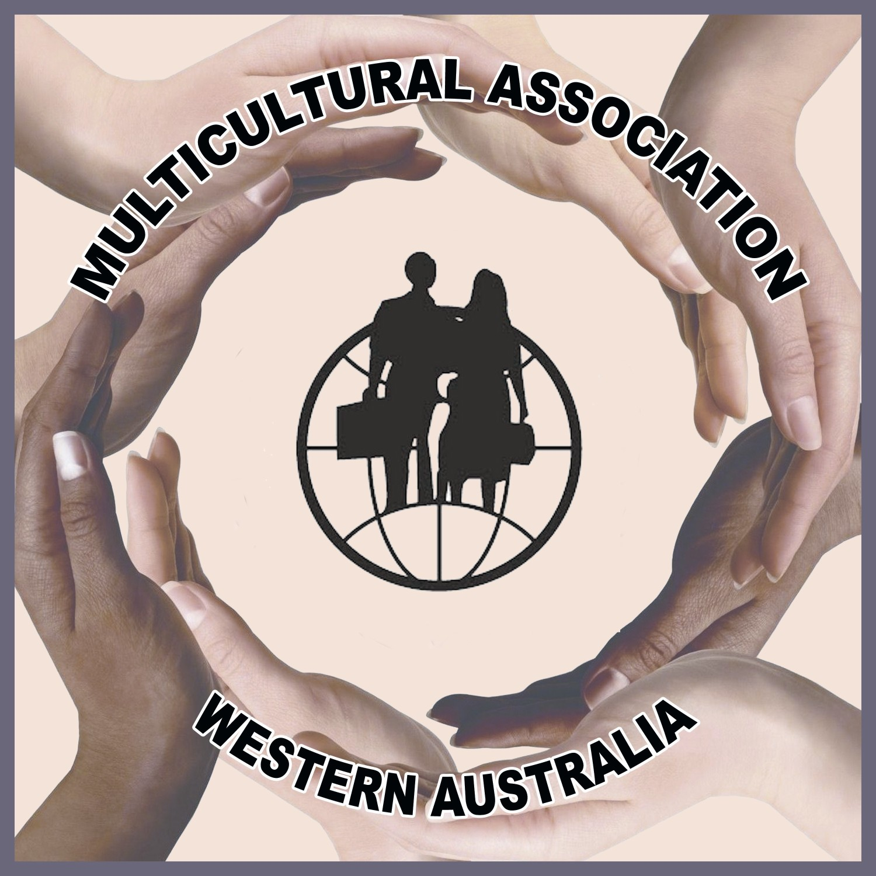

Sunday 24 October 2021 2.00 to 5.00pm
Paul Latham Auditorium – Churchlands Senior High School

Expression of Interest
Please return by Monday 21 June 2021

Name of Association/Group/School/Individual Name ______________________________________________________________________________

Category (Select): ◻ Dancing ◻ Music ◻ Singing

Group (Select): ◻ Primary School Age (5-12 years)
◻ Secondary School Age (13-18 years)
OR
Individual (Select): ◻ Primary Age (5-12 years)
◻ Secondary Age (13-18 years)

Ethnic/National background _________________________________

Title of performance: _____________________________________________________

Brief description of performance:_____________________________________________
________________________________________________________________________
________________________________________________________________________
________________________________________________________________________

Performance details (Please note 5 minutes maximum):

Length of performance: __________________ (minutes)
Number of performers: __________________

Technical requirements: Microphones, music stands etc
_______________________________________________________________________
NOTE: Please send us a short video that we can use for the selection of performers.
The aim is to have as many different cultures as possible.
WAMA will contact you in due course to confirm acceptance/decline of your application.

Contact details:

Name: ___________________________________________________

Tel: _________________________ Mobile: _________________________

Email: ___________________________________________________

Date: _______________ Signature: ______________________________________

Please note: 1. Responsibility for the performers during the event rests with the above person.
2. The signatory gives permission for images/video taken be used for any publicity.
Please email to WAMA Inc Secretary: secretary@wamainc.org.au
Mobile: 0468 437 787

